SAP HANA Analysis Process

To run a SAP HANA analysis process a specialized procedure on the database will be generated and triggered accordingly.
For the ABC Analysis we use an existing Composite Provider . After that, it is important to define the function for the execution of the Analysis. In this first example we use the ABC Analysis as a preconfigured function.

In the next step the target needs to be defined.
It is possible to use the following data targets:
- Analytic Index
- Data Store Object
- Database table
- Embedded in Data Transfer Process
We will use an Analytic Index to persist the results. If the Index does not exist already, it is possible to generate the index by activating the HAP. The flag to generate analytic index is set automatically if the Analytic Index does not exist already. Furthermore the flag to persist the Results in the Analytic Index is set automatically as well. If the persistence of the results is not needed this flags needs to be eliminated.

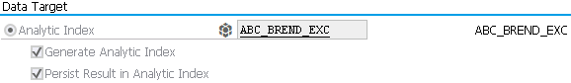

To activate the HAP press the Activation button. Now the HAP is ready to run and can scheduled via process chain 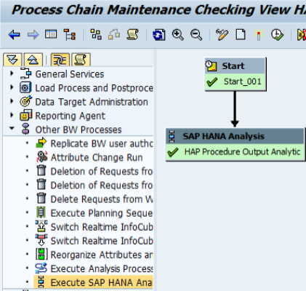 or directly executed.
In the Analytic Tab it is possible to decide if the data should load as a Full with deleting the existing data or if the new data should be add as new data to existing ones.

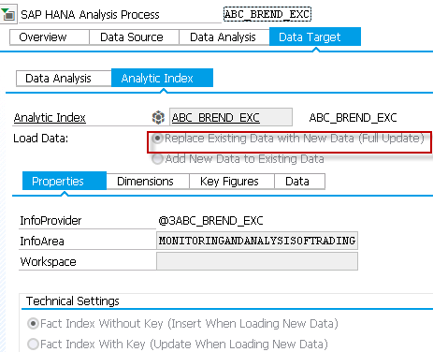

Due to the fact, that HAP are not working with scalar Input or Output parameters in the moment a slightly different AMDP is used in this example. (2017624 - Procedures with scalar input and/or output parameters are not supported).
In this example the input parameter is defined as a table and the Select statement in the SQL script is hardcoded just to demonstrate the workflow and the possibilities of this HAP.
Design the HAP – use table ZPROCEDURE as a Source 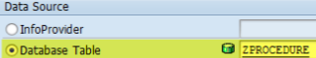. In this simple example only one value is posted in this table – this value acts as an input parameter for the AMDP and defines the number of the best and worst customers depending on the gross amount of open invoices.
The Output is defined as an Analytic Index. The Analytic Index will be generated once the HAP was activated successfully.
Map the Input parameter of the Input Source to the Input fields of the Hana procedure.

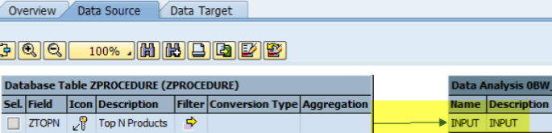

− Изменение значений групп разбиения
- Изменить значения процентов групп
- Пересчитать HAP

Analysis Process → CV
Изменение параметров (ABC Intervals percentage) Analysis Process

SAP HANA Analysis Process
Павел, добрый день,
Если возможно, просьба проконсультировать по Analysis Process.
Создал Analysis Process (ABC анализ), на нем – CompositeProvider, а из композита – Calculation View. Все хорошо, кроме одного – значения ABC интервалов фиксированы. Можно ли при вызове Analysis Process изменять значения ABC интервалов?

Адрес:
247034, Гомельский р-н, пос. Кореневка, ул. Шоссейная, 30к
Приемная: тел./факс 8 (0232) 908440

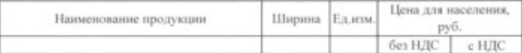
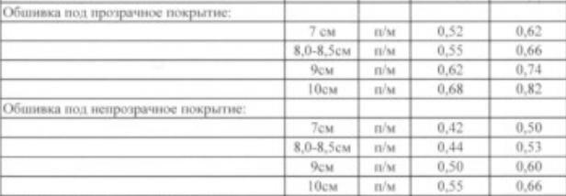

Change of ABC Intervals percentage of Analysis Process
Analysis Process ABC Intervals percentage change at runtime
of Analysis Process

change property of SAP hana Analysis Process at runtime

Пересчет HAP

.

ABC анализ

Тр. RSDMWB -

Из RSDMWB существует 3 варианта сохранения ABC анализа:

после расчета модели

Залить результат в атрибут инфо-объекта (например - 0SOLD_TO - только сначала добавить в качестве атрибута что-нибудь типа 0ABC_CALSS).

Закачать в ODS - объект.

Создать инфо источник результатов расчета и дальше с ним уже работать любым удобным способом.

Гибкость - можно забивать не 3, а на большее количество групп.
Минус - нельзя задавать группы разбиения в ABC (по крайней мере - стандартно) в виде функций, зависящих от данных.

SAP HANA Analysis Process ABC_BREND_EXC
Как изменить SAP HANA Analysis Process ABC intervals percentage через параметры?
How to change SAP HANA Analysis Process ABC intervals percentage through parameters ?
Как запустить (execute) SAP HANA Analysis Process ?

CV package_01::BCABC_BRD_EX
Инфопровайдер
0INFOPROV = @3ABC_BREND_EXC
Выборка
SELECT * FROM "PUBLIC"."package_01::BCABC_BRD_EX"

Analytic Index in BW 7.3 is created in the following cases:
- During Analytic Index Creation in APD (Analysis Process Designer)
- While creating a Composite Provider in T-CODES RSLIMO/RSLIMOBW
- While creating a Composite Provider in BW Workspace
- While publishing a SAP HANA Model in BW (the data is not stored in BW at all!)

When data in an analytic index is created, changed, loaded or deleted, this is logged in the application log under Analytic Index (AIND). The authorizations for these actions are assigned using authorization object S_RS_AINX.

− Проблема с полномочиями при превью CV

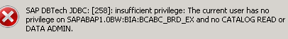

− Решение

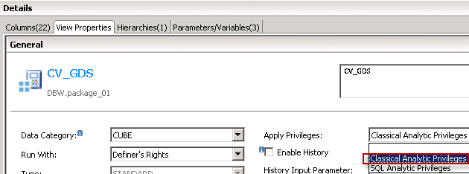

Creating TransientProviders ('trænzɪənt временный, переходный) on SAP HANA Models

https://help.sap.com/saphelp_nw73/helpdata/en/11/69442974eb49aaa08ee5c225766858/frameset.htm

Context
You can create a TransientProvider by publishing SAP HANA models in the BW system. The SAP HANA models published in the BW system are saved as an analytic index. This represents a view of the data in the SAP HANA model.
A TransientProvider is generated on this analytic index. A TransientProvider based on an SAP HANA model is suitable for ad hoc data or scenarios that change frequently.
These TransientProviders can then be linked to other BW InfoProviders in a CompositeProvider. This enables you to combine ad-hoc data with consolidated data from the BW system and also use the OLAP functions of the BW system for analysis. If the SAP HANA model is changed, the analytic index is adjusted automatically at runtime.

Note
A TransientProvider on an SAP HANA model cannot be used as a data target in Analysis Process Designer.

An analytic index created as described above is also displayed in the analytic index overview. More information - Managing Analytic Indexes

To publish an SAP HANA model in the BW system, the system reads the structure of the SAP HANA model from the SAP HANA database. The BW system applies the structure to an analytic index. Models from any schema can be used here. The system automatically maps the authorizations from SAP HANA to the BW analysis authorizations.
In the SAP HANA database, analytic privileges are used to define which users are allowed to view which data records for analysis purposes. Analytic privileges are handled as filters for database queries. Users only see the data for which they have an analytic privilege. In BW, however, authorizations do not work as filters. Here, users can only execute a query if their analysis authorizations completely cover the relevant selection. If this is not the case, an error message is displayed. Analytic privileges are persisted on the BW system and in the SAP HANA database.
To publish SAP HANA models on the BW system, a generic R/3 user needs complete authorization for the SAP HANA model.
The user specified in the BW system is used for read-only access during the execution of a query. The analytic privileges of this user are checked in the SAP HANA model. The analysis authorizations are also checked in the BW system when an InfoObject is assigned. If a TransientProvider characteristic has restrictions on analytic privileges and on analysis authorizations, the conditions are joined using Union.

Note
The BW database user is always used every time the SAP HANA database is accessed. The BW database user and the BW user must be identical (1:1 user mapping), so that the analytic privileges of a BW database user can be mapped to the virtual analysis authorizations of a BW system user.

More information -
- Analysis Authorizations
- BAdI for Virtual Analysis Authorizations

For more information about analytical privileges, see http://help.sap.com/hana in the SAP HANA Database Security Guide.

Procedure
- Run transaction RSDD_HM_PUBLISH (Опубликовать модель HANA).
- Select an SAP HANA model. The SAP HANA model is uniquely identifiable from the catalog that it is located in.

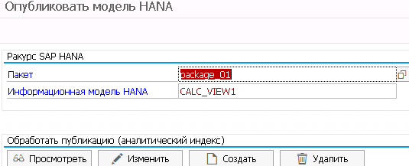

- Choose Create.
- The system uses the name of the SAP HANA model to generate a proposal for the name of the analytic index to be created. You can change this name. Choose Continue. The definition of the analytic index is displayed.
- On the Properties tab page, you can assign an InfoArea to the analytic index.
- On the Characteristics and Key Figures tab pages, you can assign BW InfoObjects to the fields. This means the metadata (of characteristics and key figures) on the flat view of the data is turned into a multidimensional view. The attributes of the referenced InfoObject are then displayed in the query. However, these attributes cannot be used as navigation attributes. It also means the authorizations on these InfoObjects are taken into account. SID are created for any master data values that do not exist in the BW system. Check/decide whether this is required.

Note
The data types of the SAP HANA model must match the data types of the InfoObject. Otherwise, no data is displayed (due to the consistency checks).
- Choose Save. The analytic index is created, and the TransientProvider is generated. It is given a generated name in the following format @3<Name_Analytic_Index>. The InfoObjects are given a generic name following the pattern <Providername>@<column_name/alias>.

Results
You can use the analytic index in CompositeProviders.

Managing Analytic Indexes

https://help.sap.com/saphelp_nw73/helpdata/en/8d/9bdcb2b5e04772b727baaa1405e10f/frameset.htm

Transaction RSDD_LTIP provides you with an overview of all available analytic indexes. You can also manage these indexes here. Here you also see the analytic indexes created in Workspace Designer and the indexes generated using the function for creating TransientProviders on SAP HANA models.
More information:
- Creating Local Providers
- Creating TransientProviders on an SAP HANA Model

You can create new analytic indexes here too.
You can see how much memory the objects use and you can delete obsolete objects.

TREX Administration
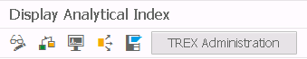
From here, you can go to the TREX Administration transaction (if using a BWA) or the DBA Cockpit (if using a SAP HANA database).

TransientProviders Derived from an Analytic Index

https://help.sap.com/saphelp_nw73/helpdata/en/11/69442974eb49aaa08ee5c225766858/frameset.htm

Concept
A TransientProvider is an InfoProvider that a BEx query can be executed on without the need for the InfoProvider to be modeled in the Data Warehousing Workbench or the data to be replicated. The modeling is derived from an application or metadata - in this case, from the analytic index. When you activate an analytic index, a TransientProvider is automatically created by the system.
The metadata of a TransientProvider is not saved. This data is generated at runtime. This means the TransientProvider is automatically adjusted when the source is changed. Therefore the TransientProvider is suitable for ad-hoc scenarios or for scenarios that are often changed. BEx queries that were created on a TransientProvider are automatically adjusted when the TransientProvider is changed. Only queries with complex formulas and restrictions might have to be manually adjusted.

Note that a TransientProvider cannot be transported - You need to create the TransientProvider/analytic index in the system where it is required.

Это в тему ошибки активации переноса –

Analytic indexes can be created in the Analysis Process Designer and in BW Workspace Designer.
More information -
in Analysis Process Designer - Creating Analytic Indexes in Analysis Process Designer
In BW Workspace Designer - Creating Local Providers

When SAP HANA models are published in the BW system, an analytic index is created that is used to generate a TransientProvider.

More information - Creating TransientProviders on an SAP HANA Model

Creating Analytic Indexes in Analysis Process Designer

https://help.sap.com/saphelp_nw73/helpdata/en/04/74bf9c461c4797bbc7a91ab12c60a0/frameset.htm

Prerequisites
You are using a SAP HANA database or a SAP NetWeaver BW Accelerator (BWA).

Context
An analytic index is a data container whose data is stored in the BW Accelerator or in the SAP HANA database.
The analytic index is used to generate a TransientProvider. This is an InfoProvider that a BEx query can be executed on without the need for the InfoProvider to be modeled in the Data Warehousing Workbench or the data to be replicated. The modeling is derived from an application, from the analytic index in this case.
Analytic indexes can be created and filled with (transformed) data quickly. They are intended for ad-hoc scenarios. They can also be created as InfoProviders without reference to InfoObjects. They are therefore not integrated into the metadata repository and cannot be transported.

Note
Note that a backup and restore process is not implemented on the system for analytic indexes. To store the data on a long-term basis, you should select a different InfoProvider type.

Note
Analytic indexes that are generated by SAP HANA models being published to the BW system cannot be used as data targets in Analysis Process Designer. The data is not stored in the analytic index in this case. It simply represents a view of the data contained in SAP HANA.

Analytic index – вьюшка для данных из БД HANA.

The analytic index stores its data in a star schema. The characteristics of an analytic index are stored in the dimensions. These dimensions can carry attributes. Last Name is a possible attribute of User for example. The analyzed key figures such as Sales or Sales Quantities are stored in the fact table and are called facts.
As well as the fact and dimension data, an analytic index can also contain authorization data. Like with analysis authorizations, this authorization data ensures that users can only display data in the query if they are authorized. When data in an analytic index is created, changed, loaded or deleted, this is logged in the application log under Analytic Index (AIND). The authorizations for these actions are assigned using authorization object S_RS_AINX.

Procedure
- Specify an InfoArea to assign the analytic index to. The analytic index is not displayed under this InfoArea in Data Warehousing Workbench, but the assignment is required to open a query in Query Designer.
- Select a loading type. You can load the facts with or without keys. Without keys, new data records are always added. With keys, data records with new key combinations are added, while data records with existing key combinations are changed.

Tab Page Dimensions –

- If you have selected Fact Index with Key, you can flag the dimension as part of the key. If this flag is set, the dimension is added to the physical fact index as part of the key. When loading a new record to the fact index, it overwrites any existing records that have exactly the same key parts.
- By choosing Attributes, you can assign attributes and flag them as navigation attributes. Attributes can be used to display other properties for selection or query navigation.
- You can assign InfoObjects - This results in the metadata on the flat view of the data becoming a multidimensional view.
The assignment supports you in the following two scenarios -
- When loading data - The assigned characteristic makes it possible to assign fields automatically in Analysis Process Designer in order to connect the source structure with the target structure for the analytic index. You can also change the assignment by specifying the characteristic name instead of the dimension name when loading authorization data.
- In Reporting - If you have set the Reference InfoObject flag for the dimension, the properties of the characteristic will be used for the analysis, meaning that display attributes and hierarchies can be used. To do this, you need to make sure that all dimension data also exists in the characteristic master data.
- You can set the Reference InfoObject Metadata flag.
- Transient InfoObjects OLAP reporting are derived for from the dimensions and key figures of an analytical index. These InfoObjects therefore do not belong to the BW Repository. These transient InfoObjects can reference existing InfoObjects if you set this flag.

If this flag is set for a dimension, the properties of the referenced characteristic are used. This ensures that all master data attributes, hierarchies and authorizations for the characteristic are available during the analysis. The display attributes of the analytic index are then replaced by the InfoObject attributes. The authorizations for the referenced characteristic support "flat" conditions, but do not support hierarchies. If this flag is set for a key figure, the properties of the referenced key figure are used (like display).

Note
If this flag is set when the query is executed, the facts are converted to the data type of the InfoObject. This can cause loss of data (rounding of key figures, cutting off dimensions). You should try to make sure that these losses of data do not occur.

- You can select the dimensions as authorization-relevant. If this flag is set, the system runs a check when executing a query on the TransientProvider and navigating in a query to ensure that the user is authorized for all dimension data flowing into the result set. The data for the TransientProvider is only displayed if this is the case.
You then have to load the authorizations too.
If you have defined that the dimension references an InfoObject, the InfoObject then decides about authorization-relevance. The analysis authorizations for the InfoObject are then analyzed when the query is executed.
- You can specify a data element that allows proposals when making the field assignment in Analysis Process Designer. This is only necessary if the data source also contains data elements, for example with database tables.

Tab Page Key Figures –

- The options here are similar to on the Dimensions tab page, with the difference that the attributes in the Unit Dimension column can be entered.

Tab Page Data –

- This provides you with an overview of the data loaded so far. Under Others, you see the memory space needed by the administration data needed to create SIDs.
- By choosing Where-Used List on the Data tab page, you can see which analysis process was used to load the data in each load run. By choosing Where-Used List in the toolbar in the analytic index, you can also view the analysis processes that read the data from the analytic index and the queries that display the data.
- By choosing Monitor on the Data tab page, you can call the monitor for individual load runs. By choosing Monitor in the toolbar in the analytic index, you can view the monitor for the entire analytic index.
- Check the analytic index and activate it. When the analytical index is activated, the TransientProvider is generated and the name of the derived characteristic is displayed in the Derived InfoObject column. Below this, this dimension is displayed in a query on the TransientProvider.
The TransientProvider is given a generic name with the prefix @3.

Caution
After an analytic index has been created in a structure, it cannot be changed. Note in particular that you cannot add any new dimensions or attributes.

Сравнительная характеристика SAP BW, SAP HANA и SAP BW на HANA как платформ для поддержки и принятия решений

https://sapland.ru/kb/articles/spj/sravnitelinaya-harakteristika-sap-bw-sap-hana-i-sap-bw-na-hana-kak-platphorm-dly.html

SAP BW Analytic Manager (ранее известный как OLAP processor) выстраивает SQL запросы в надлежащей последовательности, собирает результаты запросов и передает выполнение запросов на уровень сервера SAP HANA. Запросы BEx компилируются Analytic Manager в оптимизированные планы исполнения, что означает, что большей частью запросы выполняются в SAP HANA, а небольшая часть выполняется на уровне сервера приложений SAP BW.
Можно сохранить старую ABAP-логику в трансформациях SAP BW при миграции SAP BW на HANA. Однако, без внесения оптимизаций в систему, производительность этих программ несущественно улучшится, так как программы по-прежнему выполняются на сервере приложений практически тем же самым образом, как и без SAP HANA.
На сегодняшний день SAP HANA сама по себе не сможет заменить всю функциональность SAP BW.
На Рис. 1 внизу показана типичная архитектура (высокоуровневый дизайн) применимая к большинству внедрений SAP BW на HANA с SAP BusinessObjects в качестве инструментария фронт-энда.

Step by step Analysis Process Design

https://blogs.sap.com/2012/03/27/step-by-step-analysis-process-design/

This document explains you the idea about how to extract data from queries and tables, transform it in to required format and place it in output file (.csv) automatically by using APD process in SAP BW/BI.

Introduction

Analysis Process Designer (APD)

In SAP Business Intelligence the Analysis Process Designer (APD) makes it possible to find and identify the hidden or complex relationships between data in a simple way. Various data transformations are provided for this purpose, such as statistical and mathematical calculations, and data cleansing ('klenzɪŋ очистка) or structuring processes.
The analysis results are saved in BW data targets, file or in a FTP system. They are available for all decision and application processes and thus can be decisive (strategically, tactically and operatively).

Scenario
In this scenario we are planning to merge data from two queries, two text data base tables and combine the output based on the required format. Let’s take an example of two queries which are having material, customer, fiscal year period and sales quantity values for two regions. Material description will be fetched from text database table. The below are conditions for getting the required output
- Restrict for only few materials
- Always it should be executed from 001.2010 to current month and year.
- Material description has to be displayed as 10 chars in the report output and without ‘-’
- Display the APD execution date.

Step by Step Process

Step 1 - Create BEx Queries

Create 2 BEx Queries (i.e. Query1 & Query2) for each region wise, based on the required info objects and restricted from 001.2010 dates to current date.

Step 2 - Create APD Process
Go to RSA1 Click on APD Icon. Under Analysis Process (равносильно запуску тр. RSANWB) select General right click ‘Create’ and give the Description and click on Save it will ask for Technical name, enter and save it. In APD we have Data sources, Transformations, and Data targets which can be used based on the requirement.

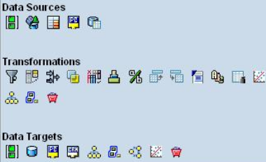

Step 3 - Configure the data source in APD
APD will support different types of data sources like Attributes, Info Providers, Query, File and Database table. In this example we are using Query and Database table as sources.

Use Query as data source
Select the data source “Use Query to Read Data” where we will give the Query names as data source. Drag & drop the “Use Query to Read Data” into Designer, then double click on it and give the Query description and click on “Choose query” to select info provider & query developed on it.
Here I have given data source description as ZTEST_QUERY1, select ZTEST query which is developed on ZTEST Infoprovider, as shown in the below screen shot.

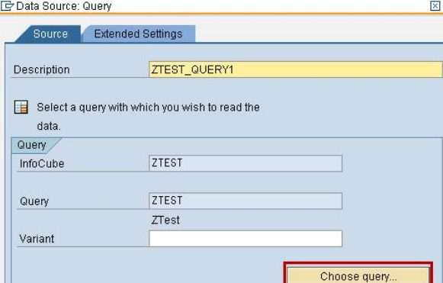

Repeat the same for Second Query i.e. ZTEST_QUERY2 also, it will be displayed as below in the Designer.

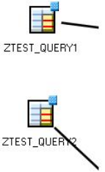

Use Table as data source
In Query we can see the attributes associated with Characteristics, but in APD we can’t fetch the attributes along with Characteristics from the query. Here query will displays characteristics only. So to fetch the material description we need to use material master data text table as source (i.e. /BIC/TMATERIAL)
Select & drag the ‘Read data from data base table’ object from the Data Sources. Right click the object and enter the Description and Database table names. Here I have given data source description as ZTEST_QUERY1 Material, see the below screen shot.

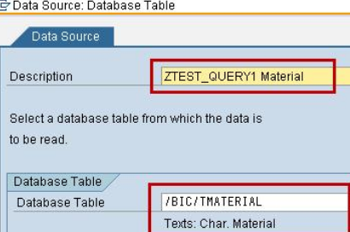

Repeat the same for Second table i.e. ZTEST_QUERY2 Material also; it will be displayed as below in the Designer.

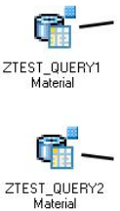

Step 4 - Use Filter to restrict Language Specific Description and Materials
Material text table (i.e. /BIC/TMATERIAL) will have different languages, to restrict the language specific to English, and specific material restriction in the output we will use Filters. Select and drag the Restrict amount of data filter from Transformations - 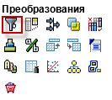 and give Material table data source as Input to this filter.

Field Selection Tab
Enter the Description of the Filter. Here I have given filter description as ZTEST_QUERY1_Filter, see the below screen shot.

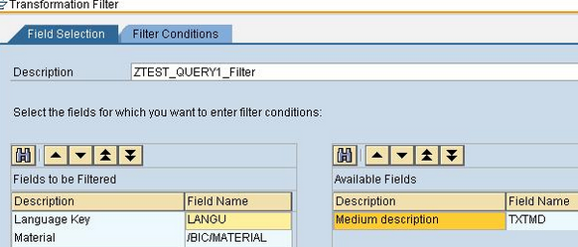

Move the list of fields on which filter has to be added from Available fields area to Fields to be Filtered area.
Here we are filtering based on Language Key and Material

Filter Conditions Tab
The selected fields for filter will be displayed in this tab. Enter the selection values which needs to be filtered. Here we are Filtering Language key as EN and Material list from 200-000-121 to 200-010-950.

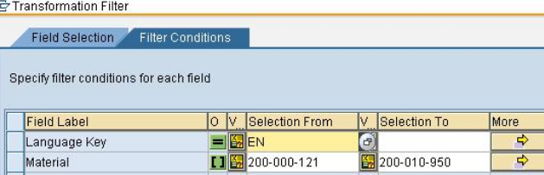

Repeat the same for Second filter i.e. ZTEST_QUERY2_Filter also, it will be displayed as below in the Designer.

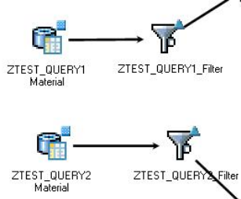

Step 5 - Joining Data from Different sources
Now we are having two data sources, one is from Query output and other one is Material Text table.
Select Join data from two data sources (join) from Transformations in 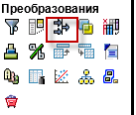 to designer and connect this to Material text and Query outputs as inputs. Select it and right click go to properties and give the Description.
Then connect the respective fields to each other based on the requirement. Here we are joining Material in Query and material in Text table as key fields.

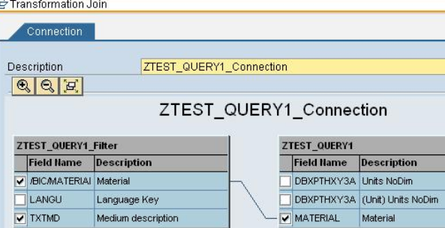

Repeat the same for Second Query i.e. ZTEST_QUERY2.

Step 6 - Define ABAP Routine to update Current date & Material Description
Material description only with 10 chars without ‘-‘ and Execution date (i.e. APD run date) has to be displayed in the output. To achieve this we need to pull ABAP Routine object from the Transformations in to designer place.
Select ZTEST_QUERY1_connection as input to this.
- Right click the ABAP Routine and select Properties and give the description (i.e. ZTEST_QUERY1_Routine) in General tab.
- Select Source Flds tab move the fields from Field list to Source Fields, if require move to Grouping Fields. Here we are moving material, fiscal year period and description.
- Select TargetFlds tab add a new filed as Execution Period to display the APD execution date and change the description of the fields as per the output displayed.

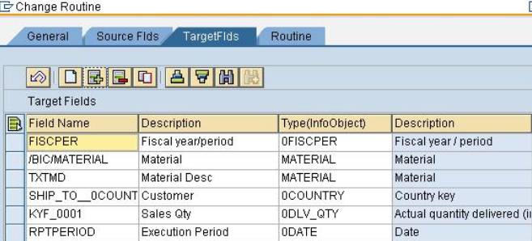

Select Routine tab add the code as shown in the below screen to format the fields, Execution Period and Material description.

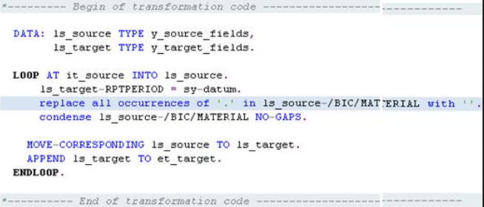

Check the code and click on ‘Ok’.
Repeat the same for Second Query i.e. ZTEST_QUERY2 also.

Step 7 - Define Aggregation of Data
Aggregate the data based on material and customer, to do this selects the Aggregate data object from transformations and place in designer. Connect ZTEST_QUERY1_Routine as input to this.
Right click on Aggregate data and select Properties.
Enter the Aggregation description as ZTEST_QUERY1_Aggregation. Based on grouping move the fields from Available fields panel to Selected Grouping Fields and move the key figure which is to be aggregated to Selected aggregated Fields.
Click on ‘Ok’ and save the APD. Repeat the same for Second Query i.e. ZTEST_QUERY2 also.

Step 8 - Use Union to join the data sources
To combine the two data sources we will use Union object. Select Unify Data from Two Data Sources (Union) drag into designer. Union will combine the two data sources based on similar properties.
Connect the ZTEST_QUERY1_Aggregation and ZTEST_QUERY2_Aggregation as input to Union and give the description as ZTEST_Union click ‘Ok’ and save the APD, it will be displayed as below in the Designer.

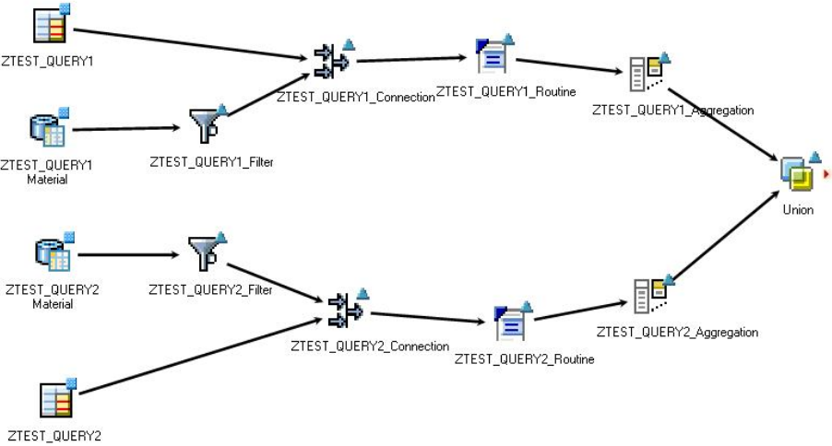

Step 9 - Define the Data Target
APD will support different types of data targets like Attributes, DSO, CRM attributes, Decision Tree, Clustering Model, Analysis model, Scoring model, 3rd party data mining model. In this example we are using File as data target.
So now we need to define the output file target. We can define target as Application server (i.e. using Logical file name) or Client location. In this example we are using target is Client Location. Select Write data to File object from Data Targets and place it in the Designer, give the ZTEST_Union as input. Right click and select Properties. In The Data Target tab enter the Description as ZTEST_Data_Target, choose Client Work location and give the output file path.
Here we can select Write mode based on the requirement (i.e. each time new file or over write the existing one). In this example we are selecting Create File Again. If Already Available - Overwrite. Click on CSV File Properties tab, enter the Data separators and Separator Field Name/InfoObject.
Once it is done click on ‘Ok’ and save the APD. Finally the APD looks like below

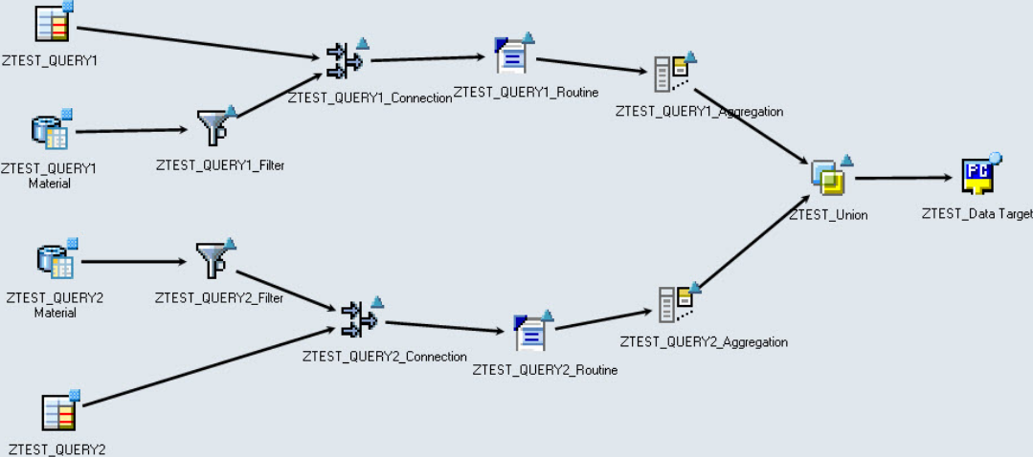

Check the APD and activate and execute it. The below is the display of output file.

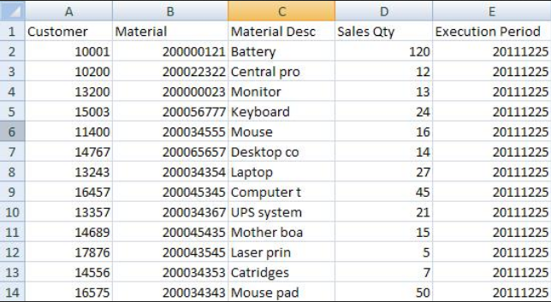

Yandex диск
https://disk.yandex.ru/?source=landing2_disk30_ru

login = ekimenkoaleksej
shm7072

